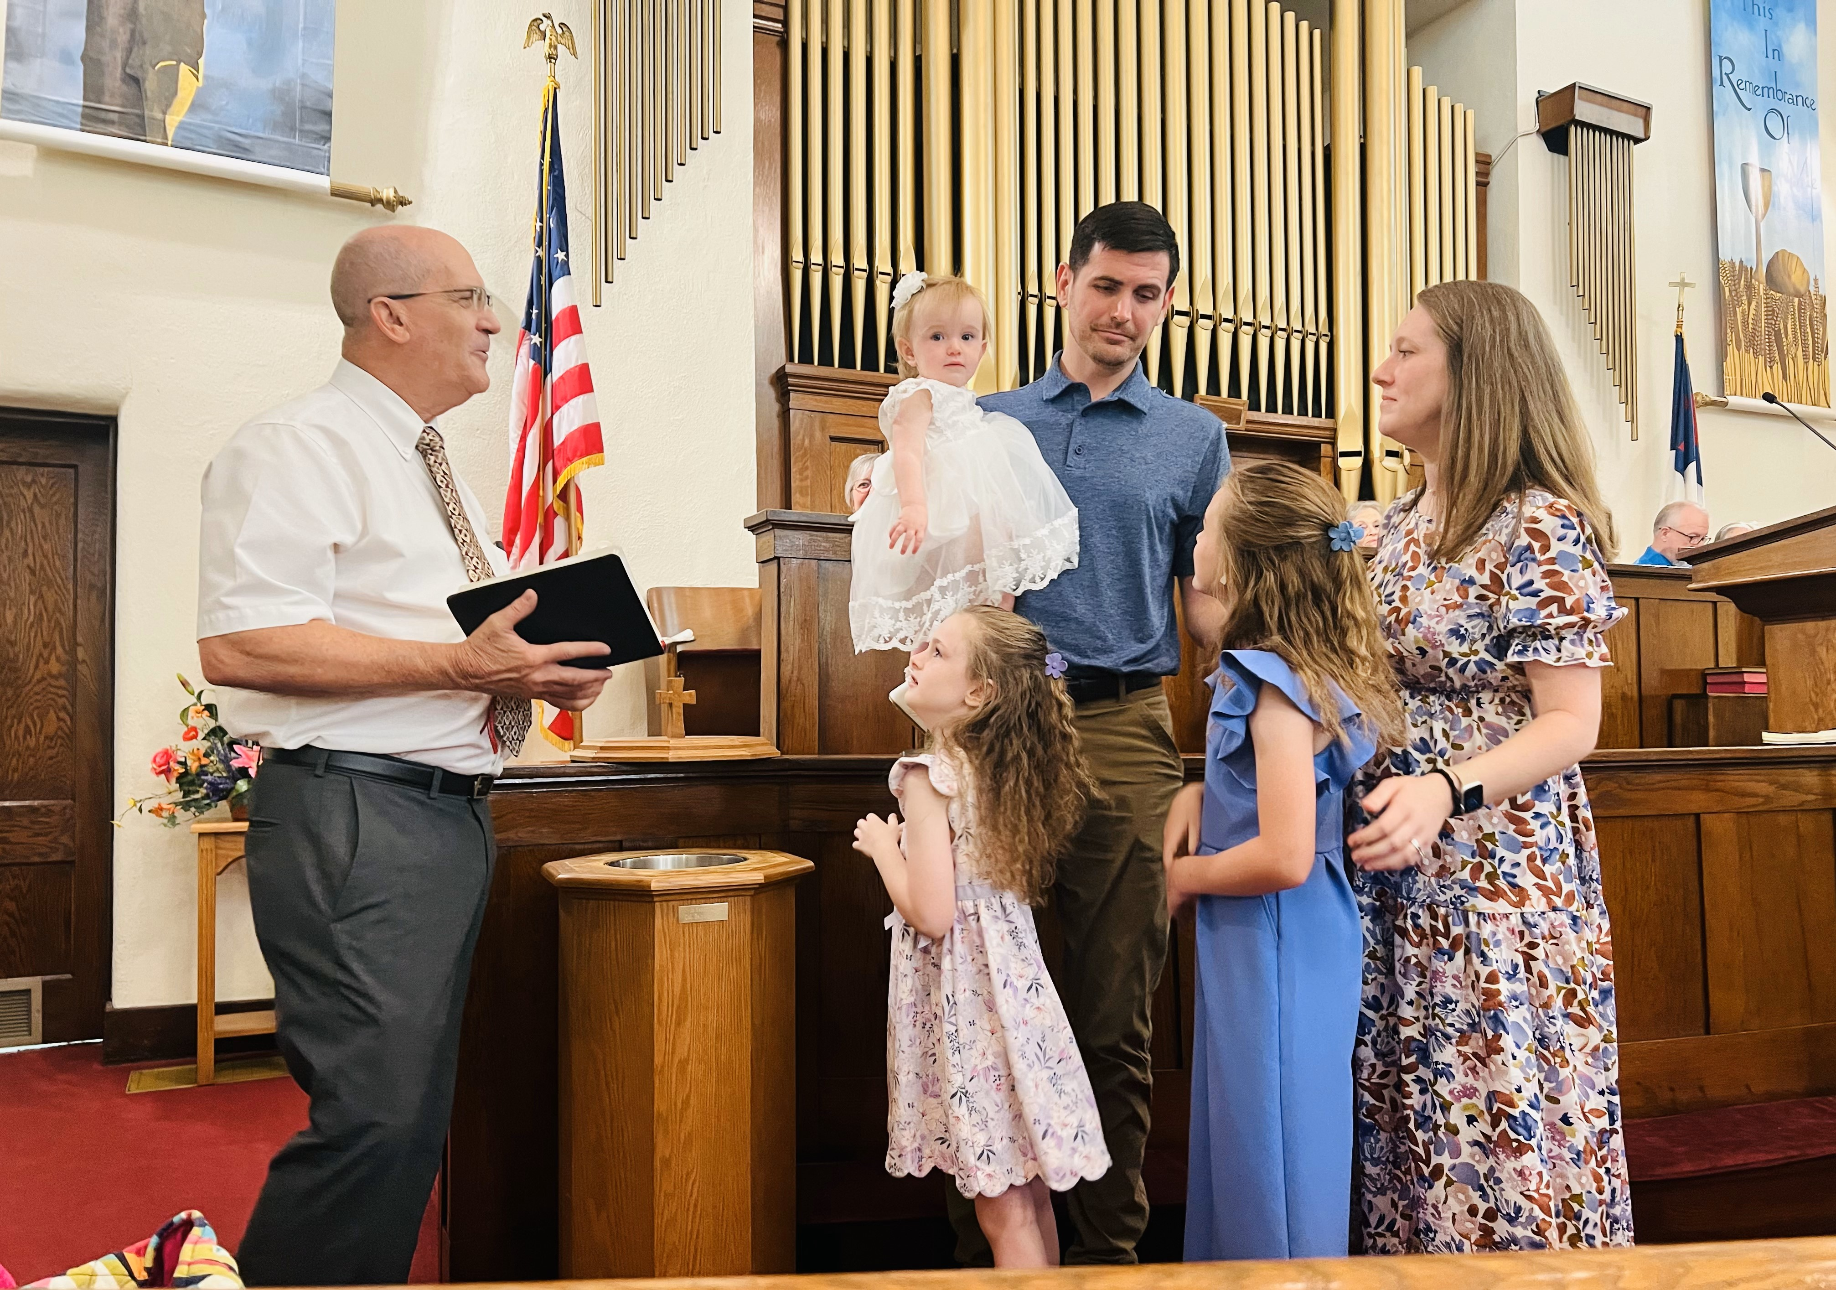
Pictured above are Joshua and Kayla Manatt, and their children Mallory, Abigail, and Caroline. Caroline was baptized and brought in as a constituent member until she can profess her own faith in our Lord. Peggy Sheets is her great-grandmother, and Steve and Jill Sheets her grandparents.

Rio Bravo Mission Team is Away

Please give prayerful attention to our mission team who are traveling to spend June 2nd through the 8th in Rio Bravo, Mexico. In the meantime, Kent Tallent will be filling the pulpit on June 2nd, and Kelsey Castillo will be filling it June 9. We will have Bro. Jim and others back with us on June 16, and we will be celebrating Holy Communion on that Sunday.

Summer Giving

The Summer Doldrums usually hits with the hot weather and vacation plans this month. Please be faithful in your giving of tithes and offerings during our summer months as many will be away, and some will be worshiping on Mt. Nebo. Nevertheless, utilities run higher in the hot weather, and bills don’t take a break when you do. So, if you have to miss being with us, please remember to be faithful in your regular giving. Thank you!

“Brother Jim, Are You Really Retiring?”

The answer to the question I have been asked frequently is, “Yes, I am retiring from full-time pastoral ministry.” Nevertheless, old pastors don’t quit, for the Lord still has much for them to do. Over the last 33 years I have served as a Lay Speaker, a Prison Chaplain, a mission founder of Delta Missions, a Supply Pastor, a Student Local Pastor, an Associate Pastor, and Pastor. I have had the pleasure of serving eight church congregations, and thousands of congregants. I have had the good fortune to be a Circuit Elder and Pastor Mentor to many other pastors.
At the Trinity Conference of the GMC this June I will take on the roll of a Senior Elder and a Connecting Elder. That means I will not work full-time, but will work at the pleasure of the Presiding Elder as part of his staff who work with churches as need requires. I will still be doing charge conferences, filling pulpits, leading mission trips, and encouraging new church starts.
But, that also means I will have more time to visit family, be with grandkids, work in the garden, and travel with my wife, Cindy.
We have been so blessed by our time with the Liberty Hall, Dardanelle, and Chickalah churches. I can say this despite four difficult years where we went through the pandemic, rose to face the challenge of disaffiliating from our previous denomination, and charted a new course for our future. Know that I will continue to pray for your lives, ministries, and the challenges that still remain.
All I can say is that wherever God has led me, a church family was always there to share in our joys and our sorrows. We walk by faith, and not by sight. Nevertheless, we know that God is right there with us guiding our steps along the way. I know and trust that God will be with us into the future. Thank you, thank you for giving me the honor of serving you and your families!

New Member Sunday, June 30

Even though it will be my last regular Sunday with you, I do want to offer an opportunity to join the church at the end of the service. If you have been visiting and want to move your membership to our church, you will be welcomed. If you don’t know how this can be done, please contact me by filling out one of the new member inserts found in your bulletins on June 16, 23, or 30. We would love to have you become a regular part of our worship, mission, and fellowship!

A Few Reflections on Recent News
(Handed out as a bulletin insert on May 5, 2024)

I feel sure that you have already heard some of the rumblings of change which inevitably were to come from the United Methodist Church’s General Conference. The media has made a lot of hay out of their removal of our belief that homosexuality is incompatible with Christian Scripture, and the removal of prohibitions against LGBTQ clergy and non-scriptural matrimony in the local church. I am saddened that the UMC left traditional believing Methodists no choice but to leave their sinking ship. But more to the point, how did religious beliefs diverge so much?
The root of our disagreements of faith sprouted in the 15th century, and its key feature is the breakdown of the structure of authority, order, and meaning. The reformers challenged the authority of Catholic Church and insisted on sola scriptura, or scripture as the sole authority in matters of belief and practice. But with the concurrent availability of scripture to common people, soon everyone had their own interpretation of scripture. Reform movements quickly splintered into different groups based upon differing interpretations of scripture.
That divergence in interpretation has now blossomed into over 217 identifiable denominations in the United States, not to mention thousands of individual non-denominational churches. An appeal to the authority of scripture for many has ended up being an appeal to idiosyncratic and ever-changing interpretations of scripture. For these reformers and their successors who founded the United States, political authority arose from the people themselves acting together, not from some scriptural pattern. Suddenly every person was his/her own ruler, and acting together they overthrew kings and princes, formed political parties, and created a nation in search of moral authority.
What philosophers sought in freeing the human mind from the chains of tradition, they anchored by establishing doubt in any and all knowledge. Then science arose to claim its own authority based solely upon what observation can prove. Human self-understanding was now free to question all authority, including the Holy Scriptures. Truth became an orphan that was claimed by everyone.
We now live in an era in which our personal feelings and desires are considered and consulted to form our own truth. Nevertheless, the truth must rest upon some solid foundation, or it is liable to crumble beneath the weight of our nonsense.
Religious scholars have impressed upon their students a distrust of scripture that doesn’t agree with their world-view. It was inevitable that they would seek a default definition for truth founded in the word love, for who can argue against love? And in fact, love is central in Christian belief. The Church is a hospital for sinners, and we are all sickened by sin. We are to love the sinner, but not the sin.
However, confusion has entered the debate over love being the guiding authority for living, because of the misapplied notion that we should just love everyone (which we should), and that we should affirm one another’s chosen lifestyles (which we should not). Therefore, the siren calls of diversity and inclusion at any cost have been steam-rolled over common sense. According to our Constitution this is a civil right to be pursued. According to the Bible this is detestable and to be avoided. That same notion about love whitewashes over the deadly effects of sin and rebellion, and scoffs at the idea that God will judge our thoughts and deeds. Therefore, today’s debate has devolved into a contest about who loves most. The truth is that God loves us more than we love one another. And into a world deficient in true love, He sent Jesus—a light of truth in the darkness of our selfishness, and a sacrifice that calls us back to holy living.
Friends, my foundation remains the Holy Scriptures, and in the God who came as Jesus as my foundational truth. In fact, Jesus told those who followed him, “I am the Way, the Truth, and the Life.” His Way is the Truth, and only He gives Life to those who listen to His voice. We live in an age where many have lost their way, and to them the Bible has become just one voice among many that purports to know the way. I can’t claim some superior knowledge that gives me all knowledge, but I can point to Jesus who can lead us to all truth. I stand with those who insist on sola scriptura, and that the Bible still identifies truth from lie, life from death, and a path back to God through our Savior. May we value the gift given us by the hands who wrote by the inspiration of God’s Holy Spirit!

Bro. Jim

